**LOCAL INSTALLATION**

Prerequisites:

* Sql server 2019 (v 15.0.2000.5)
* Sql Server Management Studio v.17 or latest
* Visual studio 2017 or latest
* .Net Framework 4.6.1
* Visual code or whatever source-code editor

Additional information (folder structure)

Main > backend > **ApiLocation** (backend project)

> Database script > **script.sql** (script)

> Frontend > **cityguidetour** (front end project)

> Postman collection > **ApiLocation.postman_collection.json**

Installation steps:

1-Database creation:

* Open SSMS
* Add new query
* Paste the Sql script provided : **script.sql**
* Run the script

***Expected result****: you should have a new database create name* ***LocationDB*** and the following table with data inside.

*:* 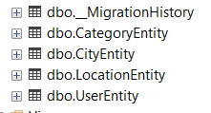

2- Backend configuration:

* Open the back end project provided named **ApiLocation** on visual studio
* Right click the solution and then click on restore nugget packages
* Open Web.config and change your *connectionStrings* to match your own server. ( change only on the highlight place on screenshot below)



* Build solution
* Run project

***Expected result****: on* <http://localhost:58815/> you should have just a text mentioned : **Web Api ready to be call**

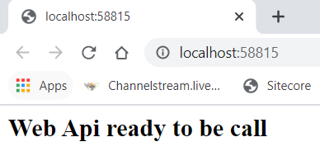

2- Postman testing:

* Open POSTMAN
* Import collection provided on folder named **postman collection**
* Open *GetlocationList* and send with request already prefilled

***Expected result****: we should have data response like the following*

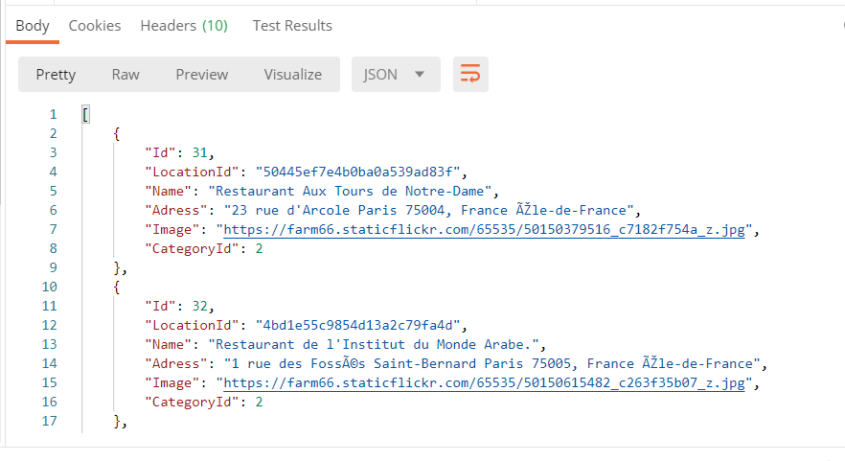

Note: you can run the others request on the collection with the same way.

3- Frontend configuration

* Open the frontend project named **cityguidetour** on you visual code
* Do **npm i**
* *Do* ***npm start***

***Expected result****: frontend project should appear on* <http://localhost:3000/> or another port mentioned

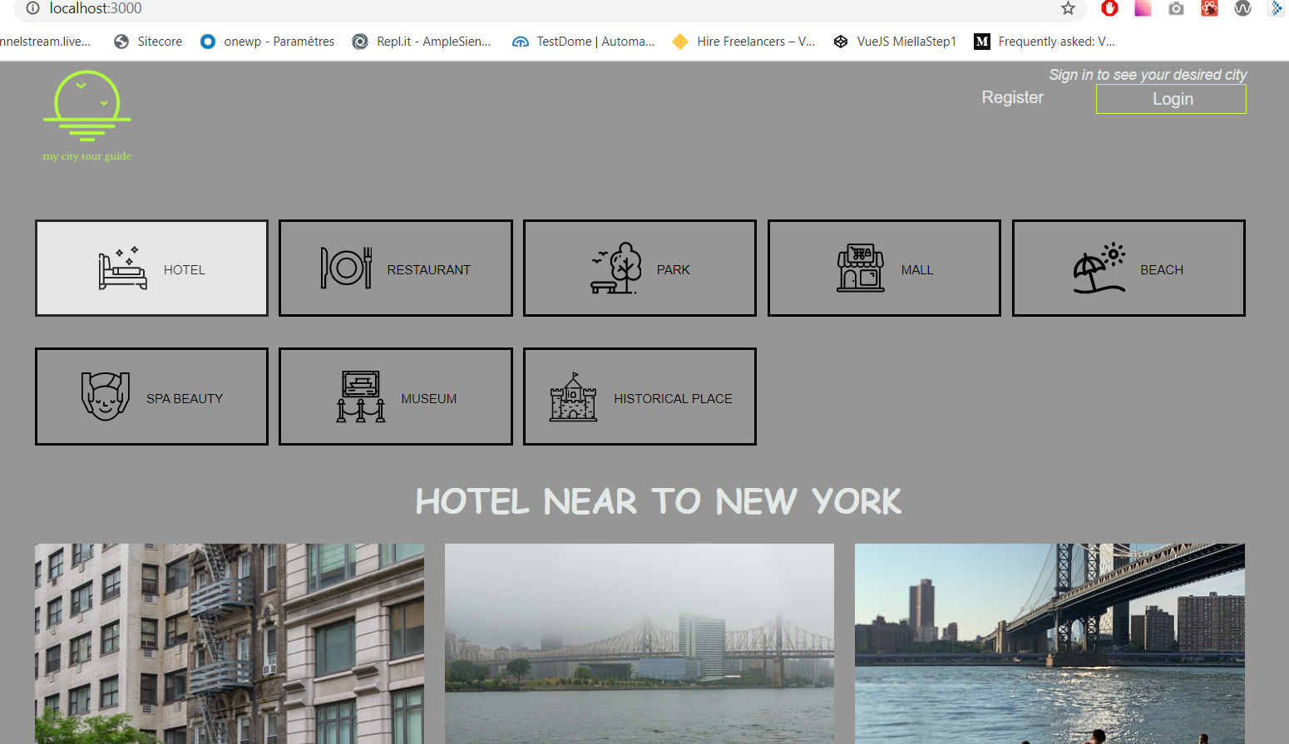

**Website quick guide**

Desktop and mobile for user not logged 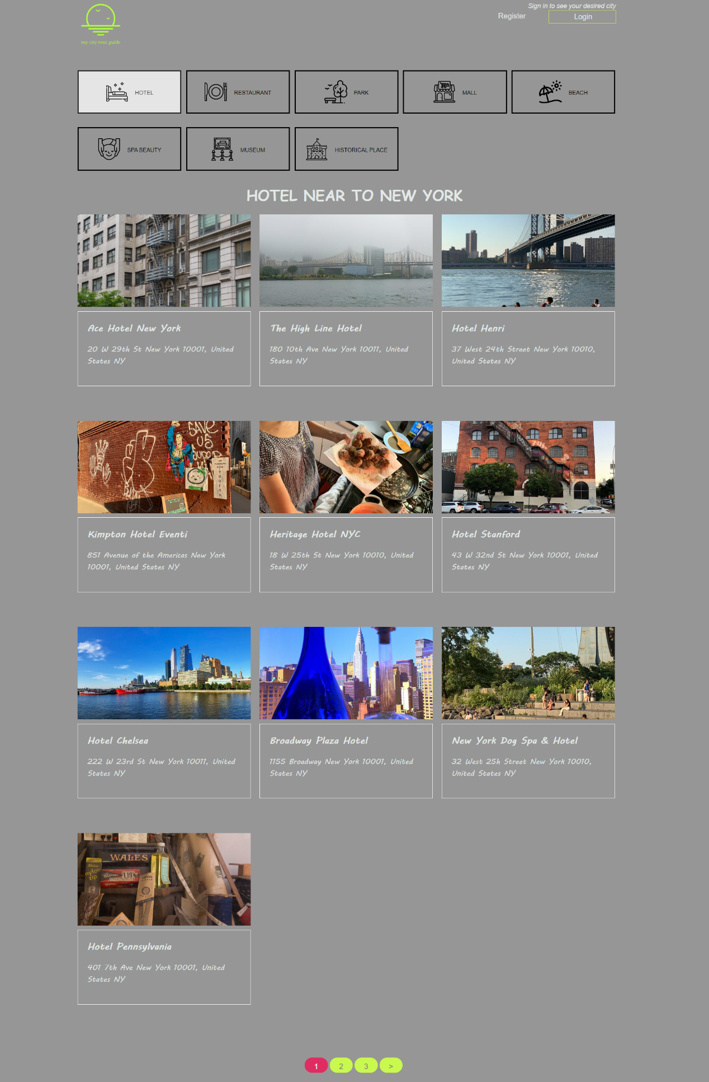 

**When user not logged** New York are the city set by default, we can find result filter by category above result list.   
  
**When logged :** (for quick log in you can use this credential : **username : user** and **password : user** or do a **registration)**

* Search bar appear invite user to search his desired city and filter ii with category provided.

Note : for now only the city capital of his country are known by the site as city.

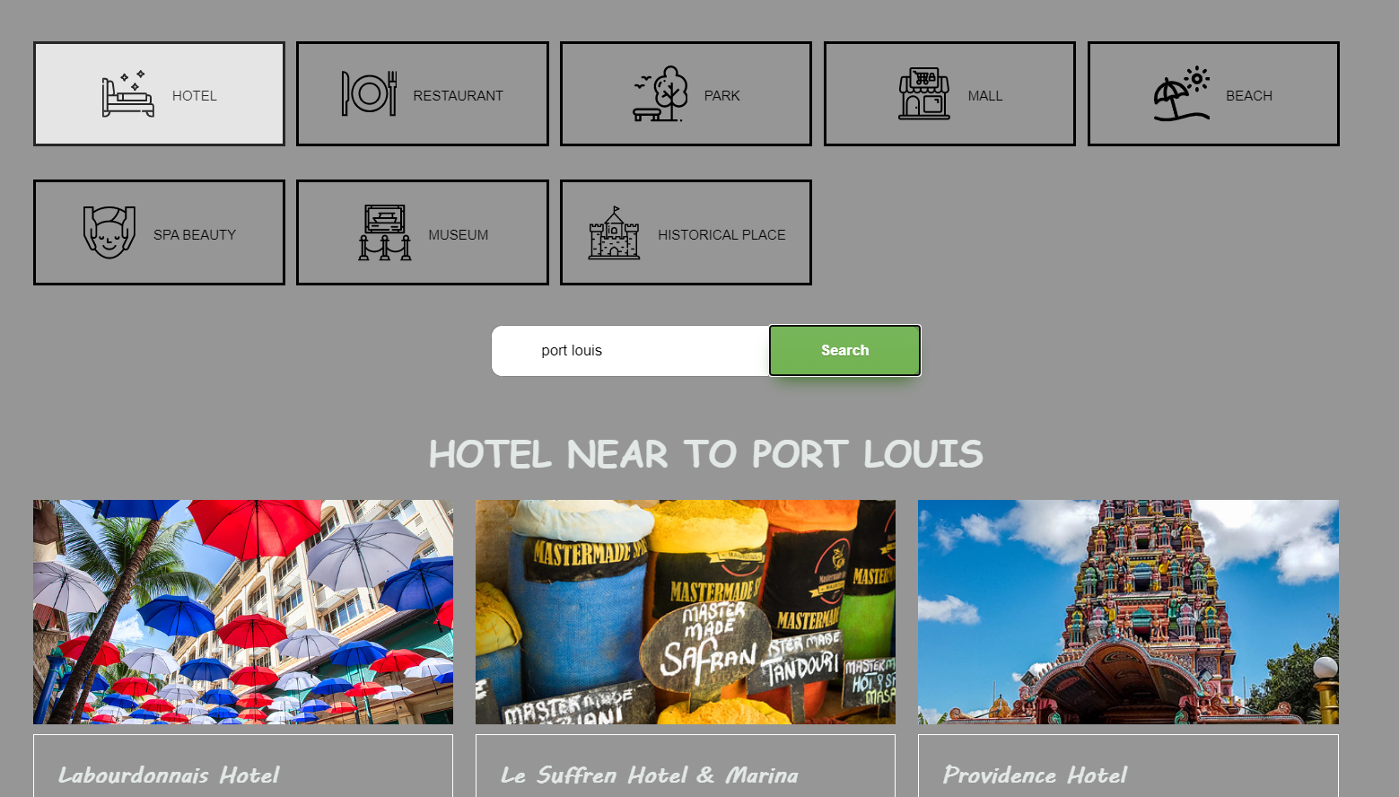

**That’s all, thank you.**